**Pull vs Push Monitoring**

* Pull Monitoring: Monitoring System pulls the information from various servers/applications/network devices the metrics.  
  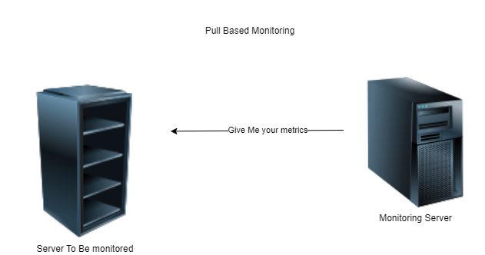
* Push Monitoring: Monitoring system get the information from various servers/applications  
  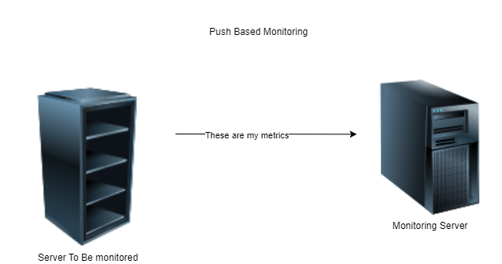
* Examples
  + Pull:
    - Prometheus
    - Nagios
  + Push:
    - Log stash
    - splunk

**Elastic Stack**

* This was called as ELK Stack
* ELK
  + E = Elastic Search
  + L = Log Stash
  + K = Kibana
* Architecture  
  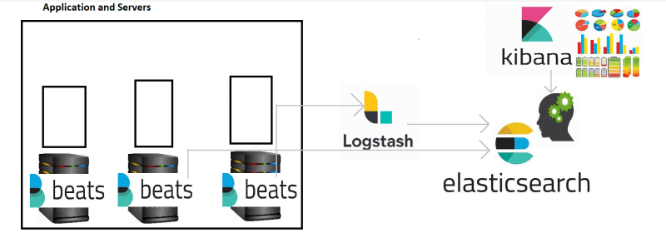
* Elastic Search: This is memory or storage system in the Elastic Stack
* Logstash: Responsible for making logs queryable
* Beats: Export metrics, logs, traces to Elastic Search
* Kibana: Creates dashboards and visualizations

**What we can monitor**

* Web Servers
  + Requests per second
  + Errors
  + Thread count
  + Response Time (Average)
* Server:
  + CPU Utilization
  + Free Memory/Used Memory
  + Disk Space
  + Disk I/O
  + Network
    - Incoming
    - Outgoing
* Databases:
  + Number of Connections
  + Size of Data Processed per second
  + Database Size